**How to add a driver in Linux kernel**

Using TCN75 for example in ATSAMA5D27-SOM1-EK

1. **Test hardware connection (in device)**

Use embedded command to test i2c

#i2cdetect -y 2

Read data from sensor directly

#i2cget -y 2 0x4C 0

1. **Kernel driver**
2. Please refer to [www.linux4sam.com](http://www.linux4sam.com) for environment setting.
3. hwmon: Hardware monitor

location: /drivers/hwmon

1. copy tcn75 driver

$cp tcn75.c $KERNEL_ROOT/drivers/hwmon/

1. modify Makefile at /driver/hwmon/Makefile

add

obj-$(CONFIG_SENSORS_TCN75) += tcn75.o

1. modify Kconfig at /driver/hwmon/Kconfig

config SENSORS_TCN75

tristate "Microchip TCN75"

depends on I2C

select REGMAP_I2C

help

Microchip temperature sensor TCN75

1. enable TCN75 driver in kernel

$cd $KERNEL_ROOT

$make menuconfig

enable [Device Drivers --->]🡺[Hardware Monitoring Support --->]



Select TCN75 driver



1. Rebuild kernel

$make

New kernel image will be placed at $KERNEL_ROOT/arch/arm/boot/zImage

1. **Device tree**
2. ATSAMA5D27-SOM1_EK hardware configuration

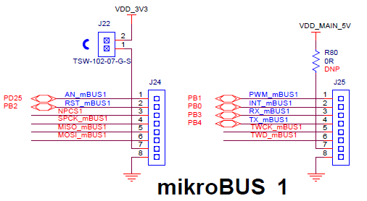 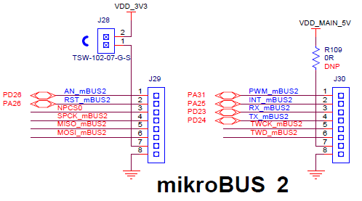

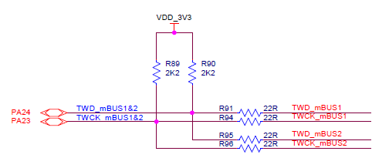



1. Device tree file for ATSAMA5D27-SOM1-EK

Location $KERNEL_ROOT/arch/arm/boot/dts/at91-sama5d27_som1_ek.dts

1. IO pin definition

pinctrl_mikrobus_i2c: mikrobus1_i2c {

pinmux = <PIN_PA24__FLEXCOM1_IO0>,

<PIN_PA23__FLEXCOM1_IO1>;

bias-disable;

};

1. Flexcom definition

flx1: flexcom@f8038000 {

atmel,flexcom-mode = <ATMEL_FLEXCOM_MODE_TWI>;

status = "okay";

i2c2: i2c@600 {

compatible = "atmel,sama5d2-i2c";

reg = <0x600 0x200>;

interrupts = <20 IRQ_TYPE_LEVEL_HIGH 7>;

dmas = <0>, <0>;

dma-names = "tx", "rx";

#address-cells = <1>;

#size-cells = <0>;

clocks = <&flx1_clk>;

pinctrl-names = "default";

pinctrl-0 = <&pinctrl_mikrobus_i2c>;

atmel,fifo-size = <16>;

status = "okay";

**temperature-sensor@4c {**

**compatible = "lm75";**

**};**

};

};

1. Make device tree

$make dtbs

The device tree file will be located at $KERNEL_ROOT/arch/arm/boot/dts/at91-sama5d27_som1_ek.dtb

1. **Update image**

Copy zImage and at91-sama5d27_som1_ek.dtb to SD card.

1. **Test**
2. When sensor driver is integrated, sensor can’t be detected and operation by i2c tool. Now issue i2cdetect to recheck.

now you can find the 0x4C is not available. It shows UU.

#i2cdetect -y 2

1. Test by system

# ls /sys/bus/i2c/devices



You can find 0x4c is placed at i2c bus 2.

get sensor data directly

# cat /sys/bus/i2c/devices/2-004c/



According to driver, the return value is multiplied 10. You need to divide by 10 to get real temperature.

1. Test by c program

Compile test program in Linux with GNU tool.

$ arm-linux-gnueabihf-gcc -o tcn75_test tcn75_test.c

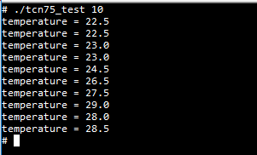Copy tcn75_test to device.